**Task 1:**

a. Proposed Software Model:

My following model is Agile model which is a way to manage a project by breaking it up into several phases. It involves constant collaboration with stakeholders and continuous improvement at every stage. Once the work begins, teams cycle through a process of planning, executing, and evaluating.

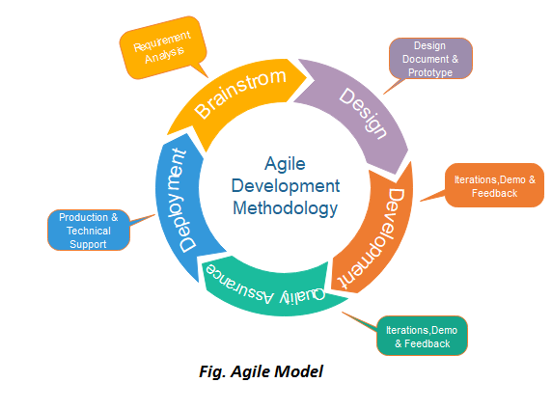

Why Should I Use Agile?

1. Quality Product

It was common to check software system before launch, however with Agile, testing is integrated throughout each stage of development to make sure a high quality end result. Continuous testing permits space for changes and may catch problems and bugs before they manifest.

2. quicker Time to promote

Sprints play a significant role once operating Agile. These set periods of your time permit groups to deliver oft and chop-chop. Speed is vital for startups.

3. Flexibility

Flexibility is praised together of the foremost helpful reasons to use Agile. as a result of the methodology permits for amendment, there's invariably space for mistakes and chance to reiterate.

4. value Effective

Becoming additional Agile is tested to save lots of cash, and most significantly, it helps you invest funds with wisdom.

5. individuals Focused/Collaborative

Agile puts a robust target individuals and collaboration, that provides the event team with several opportunities to figure with the consumer and perceive their vision.

6. Reduced Risk

Working on little tasks that build up to the large image can assist you establish problems early. Reducing risk and creating it easier to reply to any changes.

7. pleasurable Work setting

Instead of team members and shoppers operating in complete isolation for hours, everybody are operating along to deliver a high quality end result. Workshops, group action sessions, and meaningful conversations square measure all a part of the event method.

8. User Feedback

In most cases, Agile utilizes user stories to see product options. after you produce user stories, you’ll target determination the important desires users have, rather than developing options that would prove useless.

9. fast higher cognitive process

Working underneath set deadlines and timeframes can force you to get on your toes in the slightest degree times. this is applicable to higher cognitive process also, as a result of you won’t b to take a seat down along with your team to agree on each call.

10. Results Driven

Instead of that specialize in the method itself, you and your team are driven to realize milestones and results.

b. Description of every phases of the agile:

1. needs gathering: during this section, we are going to accept needs. we should always discuss on project and make a case for opportunities and arrange the time and energy required to create the project. supported this info, we will appraise technical and economic practicableness.

2. style the requirements: after we have known the project, work with stakeholders to outline needs. we are going to use the user multidimensional language or the high-level UML diagram to indicate the work of latest options and show however it'll apply to our existing system.

3. Construction/ iteration: once the team defines the wants, the work begins. Designers and developers begin acting on their project, that aims to deploy a operating product. the merchandise can endure numerous stages of improvement, therefore it includes easy, tokenish practicality.

4. Testing: during this section, the standard Assurance team examines the product's performance and appears for the bug.

5. Deployment: during this section, the team problems a product for the user's work setting.

6. Feedback: once cathartic the merchandise, the last step is feedback. In this, the team receives feedback regarding the merchandise and works through the feedback.  
Before gain ultimate success all of this process will continue like this way :

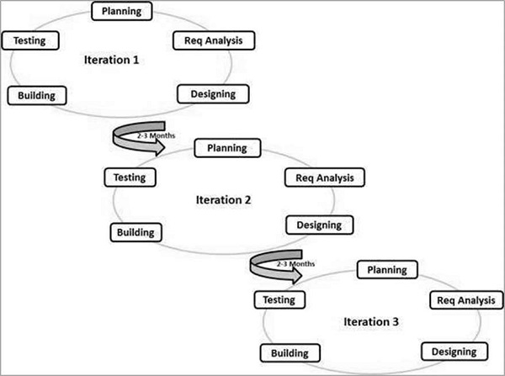

**Task 2:**

a. Some Testng Methods of my software process models are :

1.Scrum

Scrum could be a set of Agile. it's a light-weight method framework for agile development and also the most widely-used one.

A “process framework” could be a explicit set of practices that has got to be followed so as for a method to be in keeping with the framework. (For example, the beginning method framework needs the employment of development cycles known as Sprints, the XP framework needs combine programming, and then forth.)

“Lightweight” means the overhead of the method is unbroken as tiny as doable, to maximise the quantity of productive time obtainable for obtaining helpful work done.

A beginning method is distinguished from alternative agile processes by specific ideas and practices, divided into the 3 classes of Roles, Artifacts, and Time Boxes. These and alternative terms utilized in beginning area unit outlined below. beginning is most frequently wont to manage complicated code and products development, victimisation repetitive and progressive practices. beginning considerably will increase productivity and reduces time to advantages relative to classic “waterfall” processes. beginning processes alter organizations to regulate swimmingly to rapidly-changing needs and manufacture a product that meets evolving business goals. associate agile beginning method advantages the organization by serving to it to

• Increase the standard of the deliverables

• Cope higher with amendment (and expect the changes)

• Provide higher estimates whereas disbursal less time making them

• Be additional up to the mark of the project schedule and state

2. eXtreme Programming(XP)

Extreme Programming (XP) is associate agile code development framework that aims to provide higher quality code and better quality of life for the event team. XP is that the most specific of the agile frameworks relating to acceptable engineering practices for code development.

The general characteristics wherever XP is suitable area unit :

• Dynamically dynamic code needs

• Risks caused by fastened time comes victimisation new technology

• Small, co-located extended development team

• The technology you're victimisation permits for machine-controlled unit and practical tests

3.Dynamic code Development Method(DSDM)

DSDM is associate Agile methodology that focuses on the complete project lifecycle, DSDM (formally referred to as Dynamic System Development Method) was created in 1994, when project managers victimisation RAD (Rapid Application Development) wanted additional governance and discipline to the present new repetitive manner of operating.

DSDM’s success is because of the philosophy “that any project should be aligned to obviously outlined strategic goals and focus upon early delivery of real advantages to the business.” Supporting this philosophy with the eight principles permits groups to keep up focus and win project goals.

4. Feature Driven Development(FDD):

An Agile methodology for developing code, Feature-Driven Development (FDD) is customer-centric, iterative, and progressive, with the goal of delivering tangible code results typically and expeditiously. FDD in Agile encourages standing coverage the least bit levels, that helps to trace progress and results.

FDD permits groups to update the project often and determine errors quickly. Plus, shoppers will be supplied with info and substantial results at any time. FDD could be a favorite methodology among development groups as a result of it helps cut back 2 renowned morale-killers within the development world: Confusion and retread.

First applied in 1997 throughout a project for a Singapore bank, FDD was developed and refined by Jeff Delaware Luca, Peter Coad et al. the initial project took fifteen months with fifty folks, and it worked; it had been followed by a second, 18-month long, 250-person project.

Since then, it’s become a realistic approach ideal for long, complicated comes searching for a straightforward however comprehensive methodology. whereas beginning and new variations of Agile area unit additional widely known strategies (especially outside of code development), FDD will be an honest possibility for code development groups searching for a structured, targeted Agile methodology that may be scaled across the merchandise organization and can deliver clear outcomes.

Typically utilized in large-scale development comes, 5 basic activities exist throughout FDD:

• Develop overall model

• Build feature list

• Plan by feature

• Design by feature

• Build by feature

An overall model form is made throughout the primary 2 steps, whereas the ultimate 3 area unit continual for every feature. the bulk (roughly 75%) of effort throughout FDD are spent on the fourth and fifth steps – style by Feature and Build by Feature.

5. Lean code Development:

Based on agile principles, the psychodelic drug framework is employed to contour and optimize the code development method. psychodelic drug noted because the minimum viable product (MVP) strategy, as these 2 ways in which of operating area unit a great deal aligned. each will speed up development time, by focusing solely on the required deliverables, obtaining a product to promote before adding new options.

Launching with solely bare-minimum options provides groups the chance to find out from real market metrics, characteristic what works and doesn’t work for users, so rolling out new updates or redesigns supported this knowledge.

6. Crystal methodology :

Crystal is associate agile methodology for code development. It places concentrate on folks over processes, to empower groups to search out their own solutions for every project instead of being constricted with rigid methodologies.

Unlike additional fastened frameworks like beginning, crystal acknowledges that completely different groups can perform otherwise betting on team size, criticality, and priority of the project and encourages users to adapt the framework for his or her individual things.

For example, alittle team will keep itself aligned with regular communication, thus it does not want a lot of standing coverage and documentation, whereas an oversized team is probably going to urge out-of-

These are categorized by color, according to the number of people in the project;

* Crystal clear - Teams with less than 8 people
* Crystal yellow - Teams with between 10 and 20 people
* Crystal orange - Teams with between 20-50 people
* Crystal red - Teams with between 50-100 people

b.

I think DSDM is better testing method for my model. DSDM has a broader focus than most other Agile approaches in that it deals with projects rather than just the development and delivery of a product (typically software). The project context requires a focus on the wider business need and all aspects of the solution that evolves to meet that need. DSDM has a long track record of successful Agile project delivery in all types of corporate environments, and has proved to be fully scalable, working effectively in small simple businesses, large, complex organizations and in highly regulated environments. It also has been shown to be equally effective for both IT and non-IT projects, for example business change projects.

Now look at the key principles description of the DSDM:

1. specialize in the Business Need:

➢ Establish the business case through the business would like perspective

➢ produce a sound and even business case

➢ Align the business case to structure goals and priorities

➢ ask for continuous business support

➢ Validate the business commitment through results

➢ ask for managerial/business input to align the goals

➢ Guarantee Minimum Usable set (MUST)

➢ Aim for the minimum usable state

➢ produce a foundation to be engineered on in later iterations

2. Deliver on time:

➢ Timebox work activities / continually hit deadlines

➢ portion time periods to finish the work

➢ Timeboxing fastened periods of your time for every planned activity

➢ touching deadlines builds trust within the method

➢ Develop priority conversations with attention on what's required

➢ Hold conversations with business and

project stakeholders to assist confirm timelines

➢ specialize in what the business desires initial to

help meet structure goals

3. Collaborate:

➢ Involve the correct individuals at the correct time

➢ herald SME’s and consultants at points among the project once their expertise is best utilised

➢ Actively involve business representatives

➢ Gain business support through open communication

➢ Invite business leaders to conferences and inquire

about their thoughts on this state and progress

➢ Build a unified team through management

➢ take away the top-down approach to project choices

➢ The project manager is their to function a guide to the method and a supporter of communication, not the core call build

4. Never compromise with the quality:

➢ integrate quality at the start

➢ Decide as a team the minimum level of acceptable quality

➢ check early, test often, check endlessly

➢ check throughout the method to make sure quality is being met

➢ endlessly review quality goals and current level of quality

➢ Review with the team on a daily basis this level of quality and also the current quality goals

➢ alter goals as required, however ne'er sacrifice quality for time or further options (remember MUST)

5. Build incrementally from firm foundations:

➢ ensure that the answer is correct and meeting expectations

➢ Hold conversations often to indicate this resolution state and permit for input from project stakeholders

➢ make sure the project is on the correct path and alter as required

➢ alter and re-assess priorities and project viability

➢ prefer and specialize in the priorities required to create a firm foundation

➢ Building a firm foundation can additional simply leave enlargement of the project later in different iterations of the event method

➢ acknowledge that modification could occur, and adapt to that rather than fighting against it

6. Developer Iteratively:

➢ produce the robust foundation

➢ a robust solid base is less complicated to expand on later – you wouldn’t wish to create a house on prime of a broken foundation

➢ attempt new things or consider things from a distinct perspective

➢ Take others suggestions into thought

➢ acknowledge that the method is fluid and not secured in

➢ attempt things initial, experiment, be receptive changes

➢ permit detail to emerge later, instead of a robust elaborated definition at the start

➢ The project is being rough sketched in, because it progresses the sketch can become additional elaborated

7. Communicate unceasingly and clearly:

➢ Encourage effective and informal conferences

➢ specialize in the standard of the communication

➢ Encourage further input and suggestions

➢ interact in additional cooperative practices

➢ Use communication practices

➢ Use modeling or visual aids to assist make a case for your purpose

➢ Keep documentation lean

➢ voluminous documentation can ne'er get scan

➢ Document enough to let others perceive the fundamentals

8. Demonstrate control:

➢ Results homeward project chase

➢ instead of specialize in finishing every activity, specialize in the results

➢ live progress through delivery

➢ Keep project state clear and receptive anyone UN agency cares

➢ build coming up with documents out there to any or all

➢ Project state ought to be overtly and freely mentioned

➢ Proactively manage the project, endlessly evaluating progress

➢ Keep expectations under control

➢ Use AN befittingly level of ritual once coverage

Take a look on DSDM’s operating field :

✓ DSDM has been developed to deal with common issues long-faced by comes like late delivery, value overruns or the ultimate deliverables not being utterly suitable purpose.

✓ DSDM addresses these issues by making AN agile project setting that is cooperative and versatile however remaining targeted on touching deadlines and maintaining the suitable level of quality and rigour.

✓ DSDM involves all stakeholders like the business representatives throughout AN unvaried and progressive lifecycle. All personnel concerned during a project square measure given clear roles and responsibilities and work along in timeboxes to make sure the project is unbroken on schedule.

✓ DSDM strikes the balance between acting a great deal of ‘up-front’ style and acting none. DSDM believes in doing ‘enough style up-front’ so as to scale back risk however still leave the sure thing of modification.

✓ DSDM is especially sensible at being employed with different approaches. 2 outstanding samples of this square measure victimization DSDM with PRINCE2 that allows PRINCE2 to be simply run with AN agile setting and running DSDM with start that allows start to be scaled up to run on quite simply development.

So I will follow it as testing method from my software process model

**Task3:**

a.

Video link :

b.

Evolution:

I have picked Agile as my software process model. Agile has become the go-to framework for serving to app startups and development agencies maintain attention on delivering a top quality a top quality quickly and expeditiously. Agile maximizes worth throughout the event method and considerably reduces the risk of any given project. currently concentrate on options of agile methodology ,

• Agile Methodologies have overcome the normal strategies of water model by turning into versatile, fast, lean, responsive, and consistent.

• Agile methodology focuses on individuals and is additional communication-oriented

• Agile strategies ar tested terribly} dynamic setting and encourage be very versatile by adapting to the modification happening within the business.

• Agile strategies embrace regular examination in an exceedingly disciplined manner, that consequently improves the leadership qualities to spice up the cooperation.

• Agile methodology follows best practices that facilitate in obtaining high-quality software system terribly quickly.

Now give a focus on the track record of agile at 2019 :

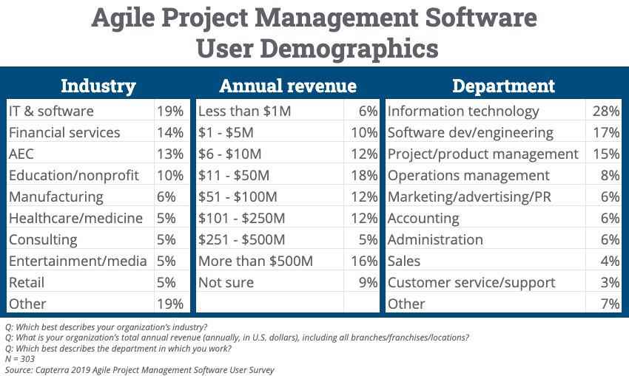

In the above chart comparatively this the best process model for the current situation . So I think I have picked the best software process model and my decision is good for the DSL.

References :

1. <https://www.javatpoint.com/software-engineering-agile-model>

2. <https://www.analyticssteps.com/blogs/7-types-agile-methodologies>

3. https://www.geeksforgeeks.org/dynamic-systems-development-method-dsdm/

4.https://www.agilebusiness.org/page/ProjectFramework_02_ChoosingDSDM/  
  
  
  
 ***The END***